2.8 Planning Proposal to Amend Orange LEP 2011 - Amendment 42 - 168 Shiralee Road
RECORD NUMBER: 2024/1258
AUTHOR: Craig Mortell, Senior Planner

EXECUTIVE SUMMARY
Council is in receipt of a proposal to amend Orange Local Environmental Plan 2011 in relation to land at 168 Shiralee Road (Lot 90 DP 750401). If supported the proposal will rezone part of the land from R2 Low Density Residential to R1 General Residential and alter the Minimum Lot Size applying to the land from a combination of 3,000m² and 200m² to become 500m². The remaining part of the land, fronting Shiralee Road would remain zoned R2 and continue to have a minimum lot size of 3,000m².
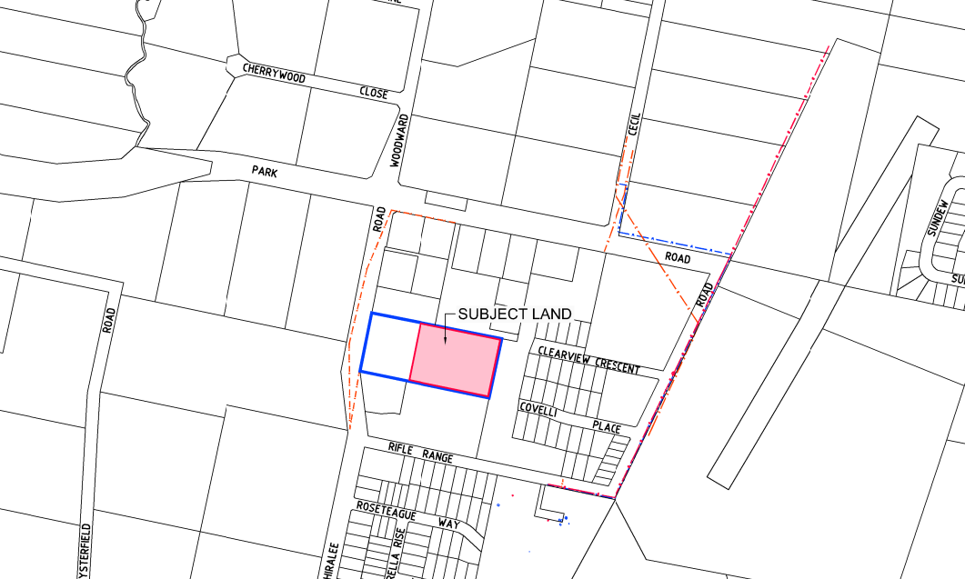

LINK TO DELIVERY/OPERATIONAL PLAN
The recommendation in this report relates to the Delivery/Operational Plan Strategy “8.1. Plan for growth and development that balances liveability with valuing the local environment”.

FINANCIAL IMPLICATIONS
Nil

POLICY AND GOVERNANCE IMPLICATIONS
Nil

Recommendation
That Council:
- Endorse the planning proposal to amend the Orange Local Environmental Plan 2011 to rezone part of 168 Shiralee Road (Lots 90 and 100 DP750401) from R2 Low Density Residential to R1 General Residential and to adjust the minimum lot size to 500m², in accordance with the proposal presented.
- Authorize staff to submit the planning proposal to the NSW Department of Planning, Industry and Environment for a Gateway Determination.
- In seeking the Gateway Determination direct staff to request delegations for the finalisation and making of the plan.
- Upon receipt of a favourable Gateway Determination, undertake public exhibition of the planning proposal for a period of 20 business days (or such timeframe as the gateway determination requires) in accordance with the requirements of the Environmental Planning and Assessment Act 1979 and the Environmental Planning and Assessment Regulation 2000.
- Authorize staff to review and consider any submissions received during the public exhibition period and make any necessary amendments to the planning proposal based on feedback received, prior to returning the matter to Council for determination

FURTHER CONSIDERATIONS
Consideration has been given to the recommendation’s impact on Council’s service delivery; image and reputation; political; environmental; health and safety; employees; stakeholders and project management; and no further implications or risks have been identified.

SUPPORTING INFORMATION / BACKGROUND
The planning proposal, to be known as Amendment 42, aims to amend the Orange Local Environmental Plan 2011 for part of 168 Shiralee Road, Orange, by changing the zoning from R2 Low Density Residential to R1 General Residential and altering the minimum lot size (MLS) from 3,000m² and 200m² to a uniform 500m².
OBJECTIVES AND INTENDED OUTCOMES
The primary objectives of the proposal are:
- Efficient Land Use: Optimize the use of land already designated for residential development. The area of land involved will see an increase in lot yield from approximately 11 lots (eight compact lots and three larger lots) to approximately 17 lots ranging from 500m² to 664m².
- Infrastructure Utilization: Make better use of urban infrastructure planned for the area. It is argued that the increased yield will contribute to a more rational use of public infrastructure.
- Diverse Housing Options: By standardizing the minimum lot size to 500m², the proposal allows for more flexible and creative subdivision designs. The 500m² lot size aligns with the existing and planned residential lot sizes in the surrounding Shiralee area, which includes a mix of larger (700m² - 800m²) and smaller lots (300m²). By aiming for 500m² - 600m² the proposal will cater for an additional segment in the market.

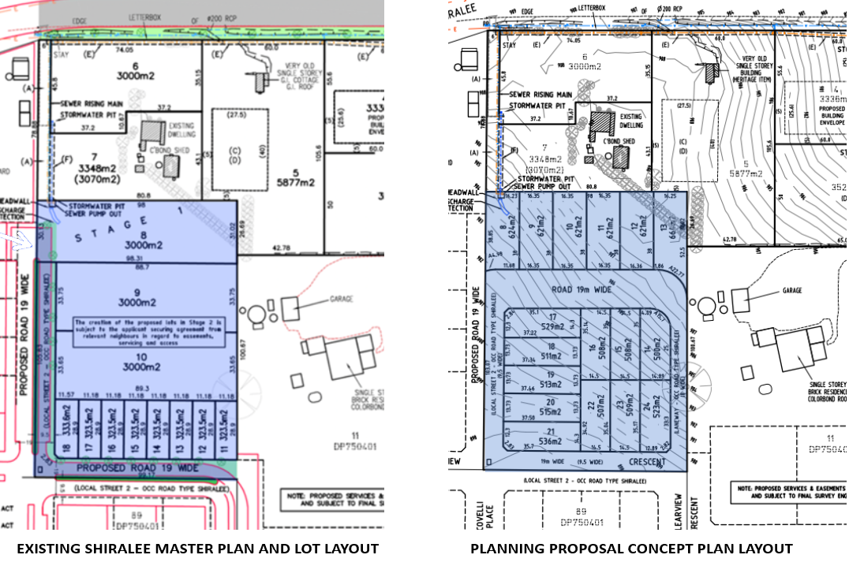
The concept layout is provided for illustrative purposes only to demonstrate that a viable subdivision can happen. However, the ultimate subdivision design will occur through a future DA assessment which may result in changes to the eventual subdivision layout potentially impacting upon lot yield.
EXPLANATION OF PROVISIONS
The proposal includes:
- Rezoning: Changing the zoning of part of the land from R2 Low Density Residential to R1 General Residential.
- Minimum Lot Size: Adjusting the MLS from 3,000m² and 200m² to 500m² across the site.
- Mapping Amendments: Updates to the LEP Land Use Zone and Minimum Lot Size maps to reflect the new zoning and lot size provisions.
NEED FOR PROPOSAL
The primary driver behind this proposal is the need to optimize land use within the Shiralee residential release area, facilitating a more efficient and sustainable urban development. The current zoning and minimum lot sizes (3,000m² and 200m²) are not reflective of the evolving residential market demand or the strategic vision for the Shiralee area. By standardizing the minimum lot size to 500m² and rezoning the land to R1 General Residential, the proposal aims to create a more adaptable residential environment. This adjustment is anticipated to support a higher density of residential development, which responds to the growing population in Orange and ensuring that urban infrastructure investments are utilized effectively.

Moreover, the proposal addresses the need for diverse and affordable housing options within the region. The existing larger lot sizes limit the potential for more affordable housing developments, which are increasingly important in addressing housing affordability issues. By enabling a greater number of more modestly sized lots, the proposal supports a wider variety of housing types and price points. This aligns with local and regional strategic planning priorities, which emphasize the importance of providing diverse housing choices to support community growth and sustainability. In summary, the proposal seeks to balance the need for efficient land use with the provision of diverse, affordable housing options, ensuring the long-term vitality and resilience of the Shiralee residential area.
STRATEGIC AND SITE SPECIFIC MERIT
- Strategic Alignment: The proposal aligns with local and regional planning strategies, including the need for residential development in already zoned areas, thereby reducing urban sprawl.
- Community Benefits: It provides a broader range of lot sizes, promoting diverse housing options and potentially more affordable housing.
- Infrastructure Efficiency: Utilizes existing and planned infrastructure more effectively, reducing the need for additional investment.
- Economic Impact: The increase in developable lots could lead to higher monetary contributions for local infrastructure and community facilities in the Shiralee release area.
COMMUNITY CONSULTATION
The proposal will undergo public exhibition and agency consultation as part of the Gateway process, expected to include:
- Exhibition Period: 28 days.
- Notifications: Notices in local newspapers and on the council’s website, outlining the objectives, affected land, inspection locations, and submission details.
- Feedback: Collection and consideration of community and stakeholder feedback to inform the final decision.
PROJECT TIMELINE
The anticipated timeline for the LEP amendment includes several key stages:
- Pre-Gateway Preparation: Initial studies and consultations.
- Gateway Determination: Formal assessment and approval to proceed to public exhibition.
- Public Exhibition and Consultation: 28-day period for public and agency feedback.
- Post-Exhibition Review: Evaluation of submissions and potential amendments to the proposal.
- Finalization: Adoption of the LEP amendment and formal updates to zoning and lot size maps.

HOUSING STRATEGY
The planning proposal aligns with the objectives and priorities outlined in the Orange Local Housing Strategy (OLHS). The OLHS emphasizes the need to cater to the growing population of Orange, which is projected to increase significantly by 2041, generating demand for diverse housing options. The proposed rezoning from R2 Low Density Residential to R1 General Residential with a minimum lot size of 500m² directly supports the strategy's goal of increasing housing supply and diversity. By allowing for lots in the medium range, the proposal facilitates a range of housing types that can cater to various demographic groups, including first-time homebuyers, families, and retirees, thereby addressing the evolving housing needs of the community.
Moreover, the proposal is consistent with the OLHS's vision of efficient land use and infrastructure utilization. The location of 168 Shiralee Road within the Shiralee residential release area is ideal for leveraging existing and planned urban infrastructure. The rezoning will enable more effective use of this infrastructure, reducing the need for further investments and promoting sustainable urban development. The proposal's emphasis on modest sized lots aligns with the OLHS's focus on housing affordability, providing options that can help mitigate the housing affordability issues identified in the strategy.
SHIRALEE MASTERPLAN
The planning proposal for the rezoning at 168 Shiralee Road aligns with and supports the objectives of the Shiralee Development Control Plan (DCP), also known as the Shiralee Masterplan. This DCP aims to guide the urban expansion of the Shiralee area, fostering a high-quality urban environment with a diversity of housing and recreational opportunities, and encouraging alternative modes of transport and healthy lifestyles.
One of the key aspects of the Shiralee Masterplan is the promotion of housing diversity to cater to a wide range of demographics and lifestyles. The plan delineates a variety of lot typologies, including larger lots to retain the semi-rural character on the peripheries and higher density, compact lots within the village centre to maximize accessibility and amenity​. The proposal at 168 Shiralee Road, by incorporating a mix of residential lot sizes, aligns with these principles by aiming to create a diverse and inclusive community.
Moreover, the Shiralee Masterplan emphasizes the creation of a distinct and identifiable community that balances urban living with the preservation of natural landscapes and open spaces. It outlines the development of green streets, pedestrian and bicycle networks, and the integration of public open spaces throughout the area​. The proposed rezoning is consistent with these objectives, aiming to enhance the connectivity and sustainability of the Shiralee precinct by integrating new residential areas into the broader urban fabric in a way that supports these key design principles.
Preliminary Contamination Investigation
The preliminary contamination investigation for the proposed residential subdivision of Lots 90 and 100 DP 750401 at 168 Shiralee Road, Orange NSW, was conducted by Envirowest Consulting Pty Ltd. The investigation aimed to assess the contamination status of the site and its suitability for residential use. The site, historically used for orcharding and grazing, covers approximately 3.8 hectares.

Key Findings
Sampling and Analysis:
- A total of 48 discrete soil samples were collected and combined into 12 composite samples.
- The soil samples were analysed for heavy metals (arsenic, cadmium, chromium, copper, lead, nickel, zinc, mercury), organochlorine and organophosphorus pesticides (OCP and OPP), total recoverable hydrocarbons (TRH), and volatile organic compounds (BTEXN).
- Additional seven discrete samples were collected from specific areas around existing dwellings and sheds.
Contaminants Detected:
- The investigation did not detect elevated levels of heavy metals, hydrocarbons, or pesticides. All samples were below the adopted thresholds for residential land use.
- No residual contamination was identified in the collected samples.
Environmental Suitability
The investigation concluded that the site is suitable for the proposed residential land use. The lack of detectable contamination suggests no significant risk to future residents, builders, or the environment. No further remediation work was recommended, as no elevated levels of contaminants were found.
ENVIRONMENTAL, SOCIAL AND ECONOMIC IMPACT
Environmental Impacts
Land Use Efficiency: The proposal aims to optimize the use of already zoned residential land by increasing the allowable density. This can reduce urban sprawl and preserve surrounding natural and agricultural areas by focusing development within an already planned residential zone.
Infrastructure and Sustainability: Improved utilization of existing and planned infrastructure such as roads, water supply, and sewage systems can enhance environmental sustainability. Additionally, the proposal supports ecologically sustainable development by promoting efficient land use and reducing the need for further expansion into undeveloped areas.
Stormwater Management: With higher density development, there will be increased impervious surfaces, potentially affecting stormwater runoff and water quality. The proposal should ensure that adequate stormwater management systems are in place to mitigate these effects, aligning with the Shiralee Masterplan's emphasis on water-sensitive urban design.
Social Impacts
Housing Diversity and Affordability: By allowing for smaller lot sizes, the proposal increases housing options, catering to diverse demographic groups, including first-time homebuyers, young families, and retirees. This can contribute to greater social diversity and cohesion within the Shiralee community.

Community Infrastructure: The proposal adds to demand for community infrastructure, such as parks, recreational areas, and local services, which are crucial for fostering a sense of community and enhancing residents' quality of life. The increased lot yield and resultant population will see an increased usage of these facilities.
Transport and Accessibility: By promoting higher density residential development, the proposal can improve the viability of public transport and active transport options (e.g., walking and cycling), reducing reliance on private vehicles and enhancing overall accessibility within the community.
Economic Impacts
Economic Growth and Development: The increase in residential lots can stimulate local economic growth by attracting new residents and investment to the area. This can lead to increased demand for and patronage of local services, shops, and amenities, boosting the local economy. The land is in close proximity to the future Shiralee shopping precinct and the added population will therefore enhance the viability of that precinct.
Infrastructure Contributions: Higher density development can result in greater financial contributions from developers for local infrastructure and community facilities, as outlined in the Shiralee Masterplan. This can fund improvements to public infrastructure, enhancing overall community amenities and services. The proposal includes a concept plan indicating an overall yield of 17 lots, up from 11 on the affected land.
Property Values: The proposal may have mixed impacts on property values. Increased density and improved infrastructure can enhance property values by making the area more desirable. However, there may be concerns about potential overcrowding or changes to the neighbourhood character, which could affect perceptions of value.
STATE ENVIRONMENTAL PLANNING POLICIES
SEPP (Biodiversity and Conservation) 2021
The proposal is consistent with the SEPP (Biodiversity and Conservation) 2021. It ensures that the development will not adversely affect critical habitats or threaten species. The planning proposal has been assessed to protect and enhance native vegetation, riparian corridors, and koala habitats. The environmental assessments conducted confirm that the proposal maintains ecological functions and aligns with the biodiversity objectives outlined in the SEPP.
SEPP (Resilience and Hazards) 2021
The proposal complies with the SEPP (Resilience and Hazards) 2021, addressing potential risks associated with natural hazards. It incorporates measures to manage bushfire risks and flood hazards, ensuring that future developments are resilient to these risks.
SEPP (Transport and Infrastructure) 2021
The proposal aligns with the SEPP (Transport and Infrastructure) 2021 by inclusion of a loop through road to enhance transport connectivity and infrastructure utilization in the Shiralee area.

SEPP (Housing) 2021
The proposal is consistent with the SEPP (Housing) 2021, supporting the objectives of providing diverse and affordable housing options. By reducing the minimum lot size to 500m² and rezoning to R1 General Residential, the proposal facilitates a variety of housing types that cater to different demographics, including affordable housing options.
Ministerial Directions

CONCLUSION
The planning proposal for 168 Shiralee Road is considered to be supportable on the basis that:
- The proposal aims to facilitate the efficient residential development of the land to optimize land use, improve infrastructure utilization, and enhance housing diversity and affordability in the area.
- The proposed rezoning aligns with the objectives of the Orange Local Housing Strategy and the Shiralee Development Control Plan, promoting diverse and affordable housing options and efficient use of existing and planned infrastructure.
- The preliminary contamination investigation confirms that the site is suitable for residential development, with no significant contamination risks identified.
- The proposal supports strategic urban planning objectives, facilitating sustainable growth and enhancing the overall liveability of the Shiralee residential precinct.

Attachments
1 Planning Proposal (redacted), D24/75306
2 Planning Proposal - Annexure A - Land Plans, D24/79306
3 Planning Proposal - Annexure B - Concept Plans, D24/79307
4 Planning Proposal - Annexure C - LEP Maps Zone & MLS, D24/79308
5 Planning Proposal - Preliminary Contamination Report (redacted), D24/75315

